

Practical No.: 9
Aim –
Implement localStorage and sessionStorage to save user preferences like theme settings.
Case Study: Create a Schedule Planner for the given table and show an alert box on click event.
Software/Tools Required –
- VSCode
- Chrome
- HTML5
- CSS3
- Javascript (ES6)
Experiment Program Code –
index.html
<!DOCTYPE html>
<html lang="en">
<head>
<meta charset="UTF-8">
<meta name="viewport" content="width=device-width, initial-scale=1.0">
<title>Theme Preferences</title>

<style>
* {
margin: 0;
padding: 0;
box-sizing: border-box;
}

body {
font-family: Inter, Arial, sans-serif;
min-height: 100vh;
display: flex;
justify-content: center;
align-items: center;
padding: 30px;
color: #172033;
background:
radial-gradient(circle at 10% 20%, rgba(99, 102, 241, 0.12), transparent 30%),
radial-gradient(circle at 90% 80%, rgba(59, 130, 246, 0.12), transparent 30%),
#f8fafc;
transition: 0.5s ease;
}

.app {
width: 100%;
max-width: 680px;
}

.topbar {
display: flex;
justify-content: space-between;
align-items: center;
margin-bottom: 18px;
padding: 0 5px;
}

.brand {
display: flex;
align-items: center;
gap: 10px;
font-size: 14px;
font-weight: 700;
color: #334155;
}

.brand-icon {
width: 32px;
height: 32px;
display: flex;
align-items: center;
justify-content: center;
border-radius: 9px;
color: white;
background: linear-gradient(135deg, #2563eb, #6366f1);
}

.status {
display: flex;
align-items: center;
gap: 7px;
padding: 7px 12px;
border-radius: 20px;
background: #ecfdf5;
color: #047857;
font-size: 12px;
font-weight: 600;
}

.status-dot {
width: 7px;
height: 7px;
border-radius: 50%;
background: #10b981;
box-shadow: 0 0 0 4px rgba(16, 185, 129, 0.12);
}

.card {
background: rgba(255, 255, 255, 0.88);
backdrop-filter: blur(20px);
border: 1px solid #e2e8f0;
border-radius: 24px;
overflow: hidden;
box-shadow:
0 20px 50px rgba(15, 23, 42, 0.08),
0 2px 8px rgba(15, 23, 42, 0.04);
}

.header {
padding: 36px 40px 28px;
border-bottom: 1px solid #e8edf3;
}

.title-row {
display: flex;
align-items: flex-start;
gap: 18px;
}

.main-icon {
min-width: 58px;
height: 58px;
display: flex;
align-items: center;
justify-content: center;
border-radius: 16px;
background: #eff6ff;
color: #2563eb;
font-size: 26px;
}

h1 {
font-size: 28px;
letter-spacing: -0.7px;
margin-bottom: 7px;
color: #0f172a;
}

.description {
color: #64748b;
font-size: 14px;
line-height: 1.6;
}

.content {
padding: 30px 40px 35px;
}

.section-title {
font-size: 13px;
font-weight: 700;
color: #475569;
margin-bottom: 14px;
text-transform: uppercase;
letter-spacing: 0.7px;
}

.theme-grid {
display: grid;
grid-template-columns: 1fr 1fr;
gap: 14px;
margin-bottom: 25px;
}

.theme-card {
position: relative;
padding: 20px;
border: 1.5px solid #e2e8f0;
border-radius: 15px;
background: #ffffff;
cursor: pointer;
transition: 0.3s ease;
}

.theme-card:hover {
transform: translateY(-3px);
border-color: #93c5fd;
box-shadow: 0 10px 25px rgba(37, 99, 235, 0.1);
}

.theme-preview {
height: 65px;
border-radius: 10px;
margin-bottom: 15px;
padding: 9px;
display: flex;
gap: 6px;
background: #f8fafc;
border: 1px solid #e2e8f0;
}

.preview-sidebar {
width: 18%;
border-radius: 5px;
background: #dbeafe;
}

.preview-content {
flex: 1;
display: flex;
flex-direction: column;
gap: 6px;
}

.preview-line {
height: 7px;
width: 70%;
border-radius: 4px;
background: #cbd5e1;
}

.preview-line.small {
width: 45%;
}

.dark-preview {
background: #111827;
border-color: #334155;
}

.dark-preview .preview-sidebar {
background: #334155;
}

.dark-preview .preview-line {
background: #475569;
}

.theme-name {
font-size: 14px;
font-weight: 700;
color: #1e293b;
}

.theme-info {
margin-top: 4px;
font-size: 12px;
color: #94a3b8;
}

.buttons {
display: grid;
grid-template-columns: 1fr 1fr;
gap: 12px;
}

button {
border: none;
padding: 13px 18px;
border-radius: 11px;
font-size: 14px;
font-weight: 700;
cursor: pointer;
transition: 0.3s ease;
}

.light-btn {
color: white;
background: #2563eb;
}

.dark-btn {
color: white;
background: #0f172a;
}

button:hover {
transform: translateY(-2px);
}

.light-btn:hover {
background: #1d4ed8;
box-shadow: 0 8px 20px rgba(37, 99, 235, 0.2);
}

.dark-btn:hover {
background: #020617;
box-shadow: 0 8px 20px rgba(15, 23, 42, 0.2);
}

.clear-btn {
grid-column: 1 / -1;
color: #475569;
background: #f8fafc;
border: 1px solid #e2e8f0;
}

.clear-btn:hover {
background: #f1f5f9;
}

.footer {
display: flex;
justify-content: space-between;
align-items: center;
padding: 18px 40px;
border-top: 1px solid #e8edf3;
background: #f8fafc;
}

.storage-info {
display: flex;
gap: 8px;
}

.badge {
padding: 6px 9px;
border-radius: 7px;
background: #e0f2fe;
color: #0369a1;
font-size: 11px;
font-weight: 700;
}

.designer {
color: #64748b;
font-size: 11px;
font-weight: 600;
text-align: right;
}

body.dark {
color: #e2e8f0;
background:
radial-gradient(circle at 10% 20%, rgba(99, 102, 241, 0.15), transparent 30%),
radial-gradient(circle at 90% 80%, rgba(59, 130, 246, 0.1), transparent 30%),
#020617;
}

body.dark .brand {
color: #cbd5e1;
}

body.dark .card {
background: rgba(15, 23, 42, 0.9);
border-color: #1e293b;
box-shadow: 0 25px 60px rgba(0, 0, 0, 0.35);
}

body.dark .header,
body.dark .footer {
border-color: #1e293b;
}

body.dark .footer {
background: #0b1220;
}

body.dark .main-icon {
background: #172554;
color: #60a5fa;
}

body.dark h1 {
color: #f8fafc;
}

body.dark .description,
body.dark .theme-info {
color: #94a3b8;
}

body.dark .section-title {
color: #cbd5e1;
}

body.dark .theme-card {
background: #111827;
border-color: #334155;
}

body.dark .theme-card:hover {
border-color: #60a5fa;
}

body.dark .theme-name {
color: #f1f5f9;
}

body.dark .clear-btn {
color: #cbd5e1;
background: #111827;
border-color: #334155;
}

body.dark .clear-btn:hover {
background: #1e293b;
}

body.dark .designer {
color: #94a3b8;
}

body.dark .status {
background: #052e16;
color: #6ee7b7;
}

@media (max-width: 600px) {
body {
padding: 15px;
}

.header,
.content {
padding: 25px 22px;
}

.footer {
padding: 16px 22px;
flex-direction: column;
gap: 12px;
align-items: flex-start;
}

h1 {
font-size: 24px;
}

.theme-grid,
.buttons {
grid-template-columns: 1fr;
}

.clear-btn {
grid-column: auto;
}

.designer {
text-align: left;
}
}
</style>
</head>

<body>

<div class="app">

<div class="topbar">
<div class="brand">
<div class="brand-icon">⚙</div>
Preferences
</div>

<div class="status">
<span class="status-dot"></span>
Preferences Active
</div>
</div>

<div class="card">

<div class="header">
<div class="title-row">
<div class="main-icon">🎨</div>

<div>
<h1>Theme Preferences</h1>
<p class="description">
Customize your interface appearance and save your preferred
theme for future sessions.
</p>
</div>
</div>
</div>

<div class="content">

<div class="section-title">Choose Appearance</div>

<div class="theme-grid">

<div class="theme-card" onclick="setTheme('light')">
<div class="theme-preview">
<div class="preview-sidebar"></div>

<div class="preview-content">
<div class="preview-line"></div>
<div class="preview-line small"></div>
<div class="preview-line"></div>
</div>
</div>

<div class="theme-name">Light Theme</div>
<div class="theme-info">Clean and bright interface</div>
</div>

<div class="theme-card" onclick="setTheme('dark')">
<div class="theme-preview dark-preview">
<div class="preview-sidebar"></div>

<div class="preview-content">
<div class="preview-line"></div>
<div class="preview-line small"></div>
<div class="preview-line"></div>
</div>
</div>

<div class="theme-name">Dark Theme</div>
<div class="theme-info">Comfortable low-light interface</div>
</div>

</div>

<div class="section-title">Actions</div>

<div class="buttons">

<button class="light-btn" onclick="setTheme('light')">
☀ Activate Light Theme
</button>

<button class="dark-btn" onclick="setTheme('dark')">
◐ Activate Dark Theme
</button>

<button class="clear-btn" onclick="clearPreference()">
↻ Reset Theme Preference
</button>

</div>

</div>

<div class="footer">

<div class="storage-info">
<span class="badge">localStorage</span>
<span class="badge">sessionStorage</span>
</div>

<div class="designer">
Design by Salim Ansari / 24070521005
</div>

</div>

</div>

</div>

<script>
function setTheme(theme) {
if (theme === 'dark') {
document.body.classList.add('dark');
} else {
document.body.classList.remove('dark');
}

localStorage.setItem('theme', theme);
sessionStorage.setItem('sessionTheme', theme);
}

function clearPreference() {
localStorage.removeItem('theme');
sessionStorage.removeItem('sessionTheme');
document.body.classList.remove('dark');
}

window.onload = function() {
var saved = localStorage.getItem('theme');

if (saved === 'dark') {
document.body.classList.add('dark');
}
};
</script>

</body>
</html>

Output –

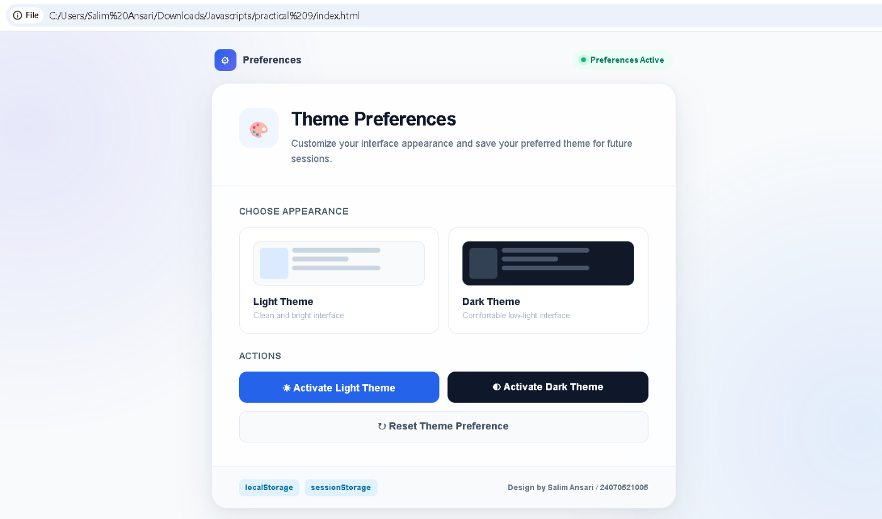
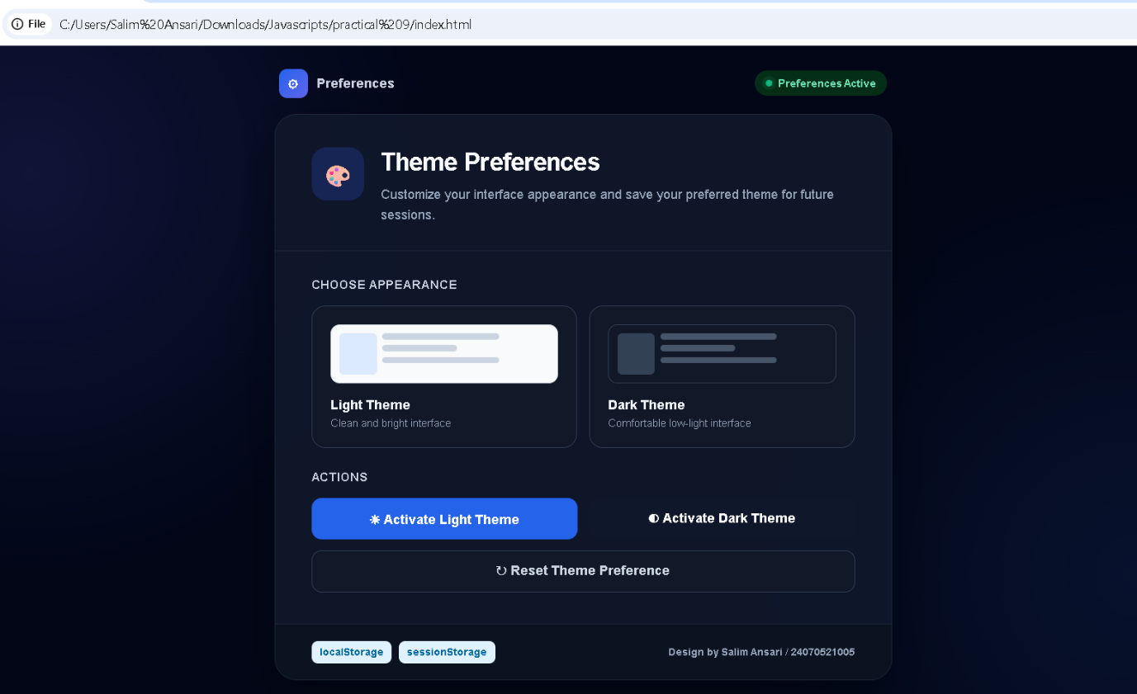
Case Study Title –
Create a Schedule Planner for the given table and show an alert box on click event.
Case Study Program Code –
index.html
<!DOCTYPE html>
<html lang="en">
<head>
<meta charset="UTF-8">
<meta name="viewport" content="width=device-width, initial-scale=1.0">
<title>Schedule Planner</title>

<style>
* {
margin: 0;
padding: 0;
box-sizing: border-box;
}

:root {
--primary: #2563eb;
--primary-dark: #1d4ed8;
--text: #0f172a;
--muted: #64748b;
--border: #e2e8f0;
--bg: #f8fafc;
--card: #ffffff;
--success: #16a34a;
--danger: #dc2626;
--warning: #d97706;
}

body {
font-family: Inter, "Segoe UI", Arial, sans-serif;
min-height: 100vh;
background:
radial-gradient(circle at 5% 10%, rgba(37, 99, 235, 0.10), transparent 28%),
radial-gradient(circle at 95% 90%, rgba(99, 102, 241, 0.10), transparent 28%),
var(--bg);
color: var(--text);
padding: 35px 20px;
}

.container {
max-width: 1100px;
margin: auto;
}

.topbar {
display: flex;
justify-content: space-between;
align-items: center;
margin-bottom: 28px;
}

.brand {
display: flex;
align-items: center;
gap: 12px;
}

.brand-icon {
width: 44px;
height: 44px;
display: flex;
align-items: center;
justify-content: center;
border-radius: 13px;
background: linear-gradient(135deg, #2563eb, #6366f1);
color: white;
font-size: 21px;
box-shadow: 0 8px 20px rgba(37, 99, 235, 0.20);
}

.brand h2 {
font-size: 17px;
color: var(--text);
}

.brand p {
margin-top: 2px;
color: var(--muted);
font-size: 12px;
}

.theme-toggle {
padding: 8px 12px;
border: 1px solid var(--border);
border-radius: 9px;
background: var(--card);
color: var(--text);
font-size: 12px;
font-weight: 700;
cursor: pointer;
transition: 0.25s;
margin-right: 10px;
}

.theme-toggle:hover {
border-color: var(--primary);
transform: translateY(-1px);
}

body.dark {
--text: #f1f5f9;
--muted: #94a3b8;
--border: #334155;
--bg: #0f172a;
--card: #1e293b;
--primary: #3b82f6;
}

body.dark {
background:
radial-gradient(circle at 5% 10%, rgba(37, 99, 235, 0.12), transparent 28%),
radial-gradient(circle at 95% 90%, rgba(99, 102, 241, 0.12), transparent 28%),
var(--bg);
}

body.dark .main-card,
body.dark .stat-card {
background: rgba(30, 41, 59, 0.94);
}

body.dark input {
background: #0f172a;
color: #f1f5f9;
border-color: #334155;
}

body.dark input:focus {
background: #111827;
}

body.dark .form-group label {
color: #cbd5e1;
}

body.dark th {
background: #1e293b;
color: #cbd5e1;
}

body.dark td {
color: #cbd5e1;
border-bottom-color: #334155;
}

body.dark tbody tr:hover {
background: #243247;
}

body.dark .day {
color: #f1f5f9;
}

body.dark .section-icon,
body.dark .empty-icon {
background: #172554;
}

body.dark .edit-box {
background: #172554;
border-color: #1e40af;
}

body.dark .edit-box h3 {
color: #93c5fd;
}

body.dark .cancel-btn {
background: #334155;
color: #e2e8f0;
}

body.dark .divider {
background: #334155;
}

body.dark .table-wrapper {
border-color: #334155;
}

.status {
display: flex;
align-items: center;
gap: 7px;
padding: 8px 13px;
border-radius: 30px;
background: #ecfdf5;
border: 1px solid #bbf7d0;
color: #15803d;
font-size: 12px;
font-weight: 700;
}

.status-dot {
width: 7px;
height: 7px;
border-radius: 50%;
background: #22c55e;
box-shadow: 0 0 0 4px rgba(34, 197, 94, 0.12);
}

.hero {
margin-bottom: 28px;
}

.hero h1 {
font-size: 36px;
letter-spacing: -1px;
margin-bottom: 8px;
}

.hero p {
color: var(--muted);
font-size: 14px;
}

.stats {
display: grid;
grid-template-columns: repeat(3, 1fr);
gap: 15px;
margin-bottom: 22px;
}

.stat-card {
background: var(--card);
border: 1px solid var(--border);
border-radius: 16px;
padding: 14px 18px;
min-height: 112px;
display: flex;
flex-direction: column;
justify-content: center;
box-shadow: 0 7px 22px rgba(15, 23, 42, 0.05);
}

.stat-label {
color: var(--muted);
font-size: 11px;
font-weight: 600;
margin-bottom: 6px;
}

.stat-value {
font-size: 24px;
line-height: 1.15;
font-weight: 800;
color: var(--text);
}

.main-card {
background: rgba(255, 255, 255, 0.92);
border: 1px solid var(--border);
border-radius: 20px;
overflow: hidden;
box-shadow: 0 15px 45px rgba(15, 23, 42, 0.07);
}

.section {
padding: 28px 30px;
}

.section-header {
display: flex;
justify-content: space-between;
align-items: center;
margin-bottom: 22px;
}

.section-title {
display: flex;
align-items: center;
gap: 11px;
}

.section-icon {
width: 38px;
height: 38px;
display: flex;
align-items: center;
justify-content: center;
border-radius: 10px;
background: #eff6ff;
color: var(--primary);
}

.section-title h2 {
font-size: 18px;
}

.section-title p {
margin-top: 3px;
color: var(--muted);
font-size: 12px;
}

.form-grid {
display: grid;
grid-template-columns: repeat(4, 1fr);
gap: 15px;
}

.form-group label {
display: block;
margin-bottom: 7px;
color: #475569;
font-size: 12px;
font-weight: 700;
}

input {
width: 100%;
padding: 12px 13px;
border: 1px solid #d5dce6;
border-radius: 10px;
outline: none;
background: #f8fafc;
color: var(--text);
font-size: 13px;
transition: 0.25s;
}

input:focus {
background: white;
border-color: var(--primary);
box-shadow: 0 0 0 4px rgba(37, 99, 235, 0.09);
}

input.error {
border-color: var(--danger);
background: #fff7f7;
}

.add-btn {
margin-top: 18px;
padding: 12px 20px;
border: none;
border-radius: 10px;
background: linear-gradient(135deg, #2563eb, #3b82f6);
color: white;
font-size: 13px;
font-weight: 700;
cursor: pointer;
box-shadow: 0 7px 18px rgba(37, 99, 235, 0.18);
transition: 0.25s;
}

.add-btn:hover {
transform: translateY(-2px);
box-shadow: 0 10px 24px rgba(37, 99, 235, 0.25);
}

.divider {
height: 1px;
background: #edf1f5;
}

.table-header {
display: flex;
justify-content: space-between;
align-items: center;
gap: 15px;
margin-bottom: 18px;
}

.table-header h2 {
font-size: 18px;
}

.table-header p {
color: var(--muted);
font-size: 12px;
margin-top: 4px;
}

.table-actions {
display: flex;
gap: 9px;
}

.search {
width: 190px;
padding: 10px 12px;
}

.clear-btn {
padding: 10px 14px;
border: 1px solid #fecaca;
border-radius: 9px;
background: #fff7f7;
color: #b91c1c;
font-size: 12px;
font-weight: 700;
cursor: pointer;
}

.table-wrapper {
overflow-x: auto;
border: 1px solid var(--border);
border-radius: 13px;
}

table {
width: 100%;
min-width: 760px;
border-collapse: collapse;
}

th {
padding: 14px;
text-align: left;
background: #f8fafc;
border-bottom: 1px solid var(--border);
color: #475569;
font-size: 11px;
text-transform: uppercase;
letter-spacing: 0.5px;
}

td {
padding: 15px 14px;
border-bottom: 1px solid #edf1f5;
font-size: 13px;
color: #334155;
}

tbody tr {
transition: 0.2s;
}

tbody tr:hover {
background: #f8fbff;
}

tbody tr:last-child td {
border-bottom: none;
}

.day {
font-weight: 700;
color: #1e293b;
}

.time-badge {
display: inline-block;
padding: 5px 8px;
border-radius: 7px;
font-size: 11px;
font-weight: 700;
}

.begin {
color: #166534;
background: #f0fdf4;
}

.end {
color: #4338ca;
background: #eef2ff;
}

.topic {
color: var(--primary);
font-weight: 700;
cursor: pointer;
}

.topic:hover {
text-decoration: underline;
}

.unavailable {
color: #94a3b8;
font-style: italic;
}

.actions {
display: flex;
gap: 7px;
}

.edit-btn,
.delete-btn {
padding: 7px 10px;
border: none;
border-radius: 7px;
font-size: 11px;
font-weight: 700;
cursor: pointer;
transition: 0.2s;
}

.edit-btn {
color: #3730a3;
background: #eef2ff;
}

.edit-btn:hover {
background: #e0e7ff;
}

.delete-btn {
color: #b91c1c;
background: #fef2f2;
}

.delete-btn:hover {
background: #fee2e2;
}

.empty {
display: none;
text-align: center;
padding: 55px 20px;
}

.empty-icon {
width: 58px;
height: 58px;
display: flex;
align-items: center;
justify-content: center;
margin: auto auto 14px;
border-radius: 16px;
background: #eff6ff;
font-size: 25px;
}

.empty h3 {
margin-bottom: 6px;
font-size: 16px;
}

.empty p {
color: var(--muted);
font-size: 12px;
}

.edit-box {
display: none;
margin-top: 22px;
padding: 22px;
border: 1px solid #bfdbfe;
border-radius: 14px;
background: #f8fbff;
}

.edit-box h3 {
margin-bottom: 18px;
font-size: 16px;
color: #1e3a8a;
}

.edit-grid {
display: grid;
grid-template-columns: repeat(4, 1fr);
gap: 12px;
}

.edit-actions {
margin-top: 15px;
display: flex;
gap: 8px;
}

.save-btn,
.cancel-btn {
padding: 10px 16px;
border: none;
border-radius: 9px;
font-size: 12px;
font-weight: 700;
cursor: pointer;
}

.save-btn {
background: #16a34a;
color: white;
}

.cancel-btn {
background: #e2e8f0;
color: #475569;
}

.footer {
display: flex;
justify-content: space-between;
align-items: center;
gap: 15px;
margin-top: 20px;
padding: 18px 5px 5px;
color: #94a3b8;
font-size: 11px;
}

.storage {
display: flex;
gap: 7px;
}

.badge {
padding: 5px 8px;
border-radius: 6px;
background: #e0f2fe;
color: #0369a1;
font-weight: 700;
}

.toast {
position: fixed;
right: 25px;
bottom: 25px;
min-width: 270px;
padding: 14px 17px;
border-radius: 12px;
background: #0f172a;
color: white;
font-size: 13px;
font-weight: 600;
box-shadow: 0 15px 35px rgba(15, 23, 42, 0.25);
transform: translateY(120px);
opacity: 0;
transition: 0.35s ease;
z-index: 1000;
}

.toast.show {
transform: translateY(0);
opacity: 1;
}

.toast.success {
border-left: 4px solid #22c55e;
}

.toast.error {
border-left: 4px solid #ef4444;
}

@media (max-width: 850px) {
.form-grid,
.edit-grid {
grid-template-columns: repeat(2, 1fr);
}

.stats {
grid-template-columns: repeat(3, 1fr);
}
}

@media (max-width: 650px) {
body {
padding: 22px 14px;
}

.topbar,
.table-header,
.footer {
align-items: flex-start;
flex-direction: column;
}

.hero h1 {
font-size: 29px;
}

.stats {
grid-template-columns: 1fr;
}

.form-grid,
.edit-grid {
grid-template-columns: 1fr;
}

.section {
padding: 22px 18px;
}

.table-actions {
width: 100%;
}

.search {
flex: 1;
width: auto;
}

.toast {
left: 15px;
right: 15px;
bottom: 15px;
}
}
</style>
</head>

<body>

<div class="container">

<div class="topbar">
<div class="brand">
<div class="brand-icon">📅</div>
<div>
<h2>Schedule Planner</h2>
<p>Seminar Management System</p>
</div>
</div>

<div style="display:flex; align-items:center;">
<button class="theme-toggle" onclick="toggleTheme()" id="themeToggle">🌙 Dark Mode</button>
<div class="status">
<span class="status-dot"></span>
System Active
</div>
</div>
</div>

<div class="hero">
<h1>Plan. Organize. Manage.</h1>
<p>Create and manage your seminar schedule with a simple browser-based planner.</p>
</div>

<div class="stats">
<div class="stat-card">
<div class="stat-label">TOTAL SCHEDULES</div>
<div class="stat-value" id="totalCount">0</div>
</div>

<div class="stat-card">
<div class="stat-label">STORED DATA</div>
<div class="stat-value">2</div>
</div>

<div class="stat-card">
<div class="stat-label">STATUS</div>
<div class="stat-value">Active</div>
</div>
</div>

<div class="main-card">

<div class="section">

<div class="section-header">
<div class="section-title">
<div class="section-icon">➕</div>
<div>
<h2>Add New Schedule</h2>
<p>Enter the details of your upcoming seminar.</p>
</div>
</div>
</div>

<div class="form-grid">

<div class="form-group">
<label>DAY</label>
<input type="text" id="day" placeholder="e.g. Monday">
</div>

<div class="form-group">
<label>BEGIN TIME</label>
<input type="text" id="begin" placeholder="e.g. 8:00 AM">
</div>

<div class="form-group">
<label>END TIME</label>
<input type="text" id="end" placeholder="e.g. 10:00 AM">
</div>

<div class="form-group">
<label>TOPIC</label>
<input type="text" id="topic" placeholder="e.g. Web Development">
</div>

</div>

<button class="add-btn" onclick="addSchedule()">
+ Add Schedule
</button>

</div>

<div class="divider"></div>

<div class="section">

<div class="table-header">

<div>
<h2>Seminar Schedule</h2>
<p id="message">Your schedules will appear here.</p>
</div>

<div class="table-actions">
<input
class="search"
type="text"
id="search"
placeholder="Search schedule..."
oninput="searchSchedules()"
>

<button class="clear-btn" onclick="clearAll()">
Clear All
</button>
</div>

</div>

<div class="table-wrapper">

<table id="scheduleTable">

<thead>
<tr>
<th>Day</th>
<th>Begin</th>
<th>End</th>
<th>Topic</th>
<th>Action</th>
</tr>
</thead>

<tbody id="scheduleBody"></tbody>

</table>

<div class="empty" id="emptyState">
<div class="empty-icon">📋</div>
<h3>No schedules found</h3>
<p>Add a new schedule or change your search.</p>
</div>

</div>

<div class="edit-box" id="editBox">

<h3>✏️ Edit Schedule</h3>

<div class="edit-grid">

<div class="form-group">
<label>DAY</label>
<input type="text" id="editDay">
</div>

<div class="form-group">
<label>BEGIN TIME</label>
<input type="text" id="editBegin">
</div>

<div class="form-group">
<label>END TIME</label>
<input type="text" id="editEnd">
</div>

<div class="form-group">
<label>TOPIC</label>
<input type="text" id="editTopic">
</div>

</div>

<div class="edit-actions">
<button class="save-btn" onclick="saveEdit()">
Save Changes
</button>

<button class="cancel-btn" onclick="cancelEdit()">
Cancel
</button>
</div>

</div>

</div>

</div>

<div class="footer">

<div class="storage">
<span class="badge">localStorage</span>
<span class="badge">sessionStorage</span>
</div>

<div>
Design by Salim Ansari / 24070521005
</div>

</div>

</div>

<div class="toast" id="toast"></div>

<script>
let editIndex = -1;
let searchText = "";

function toggleTheme() {
document.body.classList.toggle("dark");
const isDark = document.body.classList.contains("dark");
localStorage.setItem("theme", isDark ? "dark" : "light");
updateThemeButton();
}

function updateThemeButton() {
const button = document.getElementById("themeToggle");
const isDark = document.body.classList.contains("dark");
button.textContent = isDark ? "☀️ Light Mode" : "🌙 Dark Mode";
}

function loadTheme() {
if (localStorage.getItem("theme") === "dark") {
document.body.classList.add("dark");
}
updateThemeButton();
}

window.onload = function () {
loadTheme();
displaySchedules();
};

function getSchedules() {
return JSON.parse(localStorage.getItem("scheduleData")) || [];
}

function getTopics() {
return JSON.parse(sessionStorage.getItem("topicData")) || [];
}

function saveSchedules(data) {
localStorage.setItem("scheduleData", JSON.stringify(data));
}

function saveTopics(data) {
sessionStorage.setItem("topicData", JSON.stringify(data));
}

function showToast(message, type = "success") {
const toast = document.getElementById("toast");

toast.textContent = message;
toast.className = "toast show " + type;

setTimeout(function () {
toast.classList.remove("show");
}, 2500);
}

function addSchedule() {
const day = document.getElementById("day");
const begin = document.getElementById("begin");
const end = document.getElementById("end");
const topic = document.getElementById("topic");

const values = [day, begin, end, topic];

values.forEach(function (input) {
input.classList.remove("error");
});

if (
day.value.trim() === "" ||
begin.value.trim() === "" ||
end.value.trim() === "" ||
topic.value.trim() === ""
) {
values.forEach(function (input) {
if (input.value.trim() === "") {
input.classList.add("error");
}
});

showToast("Please fill in all fields.", "error");
return;
}

const schedules = getSchedules();
const topics = getTopics();

schedules.push({
day: day.value.trim(),
begin: begin.value.trim(),
end: end.value.trim()
});

topics.push(topic.value.trim());

saveSchedules(schedules);
saveTopics(topics);

day.value = "";
begin.value = "";
end.value = "";
topic.value = "";

displaySchedules();
showToast("Schedule added successfully.");
}

function displaySchedules() {
const schedules = getSchedules();
const topics = getTopics();
const tableBody = document.getElementById("scheduleBody");
const emptyState = document.getElementById("emptyState");
const message = document.getElementById("message");

tableBody.innerHTML = "";

const filtered = schedules
.map(function (schedule, index) {
return {
schedule: schedule,
topic: topics[index] || "",
index: index
};
})
.filter(function (item) {
const text =
item.schedule.day +
" " +
item.schedule.begin +
" " +
item.schedule.end +
" " +
item.topic;

return text.toLowerCase().includes(searchText.toLowerCase());
});

document.getElementById("totalCount").textContent = schedules.length;

if (filtered.length === 0) {
emptyState.style.display = "block";
message.textContent =
schedules.length === 0
? "No schedules added yet."
: "No schedules match your search.";

return;
}

emptyState.style.display = "none";
message.textContent =
schedules.length + " schedule" +
(schedules.length === 1 ? "" : "s") +
" available.";

filtered.forEach(function (item) {

const row = document.createElement("tr");

const dayCell = document.createElement("td");
dayCell.className = "day";
dayCell.textContent = item.schedule.day;

const beginCell = document.createElement("td");
const beginBadge = document.createElement("span");
beginBadge.className = "time-badge begin";
beginBadge.textContent = item.schedule.begin;
beginCell.appendChild(beginBadge);

const endCell = document.createElement("td");
const endBadge = document.createElement("span");
endBadge.className = "time-badge end";
endBadge.textContent = item.schedule.end;
endCell.appendChild(endBadge);

const topicCell = document.createElement("td");

if (item.topic) {
topicCell.className = "topic";
topicCell.textContent = item.topic;

topicCell.onclick = function () {
showToast(
item.schedule.day +
" • " +
item.schedule.begin +
" - " +
item.schedule.end +
" • " +
item.topic
);
};
} else {
topicCell.className = "unavailable";
topicCell.textContent = "Topic unavailable";
}

const actionCell = document.createElement("td");
actionCell.className = "actions";

const editButton = document.createElement("button");
editButton.className = "edit-btn";
editButton.textContent = "Edit";

editButton.onclick = function () {
editSchedule(item.index);
};

const deleteButton = document.createElement("button");
deleteButton.className = "delete-btn";
deleteButton.textContent = "Delete";

deleteButton.onclick = function () {
deleteSchedule(item.index);
};

actionCell.appendChild(editButton);
actionCell.appendChild(deleteButton);

row.appendChild(dayCell);
row.appendChild(beginCell);
row.appendChild(endCell);
row.appendChild(topicCell);
row.appendChild(actionCell);

tableBody.appendChild(row);
});
}

function searchSchedules() {
searchText = document
.getElementById("search")
.value
.trim();

displaySchedules();
}

function editSchedule(index) {
const schedules = getSchedules();
const topics = getTopics();

const schedule = schedules[index];

editIndex = index;

document.getElementById("editDay").value = schedule.day;
document.getElementById("editBegin").value = schedule.begin;
document.getElementById("editEnd").value = schedule.end;
document.getElementById("editTopic").value = topics[index] || "";

const editBox = document.getElementById("editBox");

editBox.style.display = "block";

editBox.scrollIntoView({
behavior: "smooth",
block: "center"
});
}

function saveEdit() {
if (editIndex === -1) {
return;
}

const day = document.getElementById("editDay");
const begin = document.getElementById("editBegin");
const end = document.getElementById("editEnd");
const topic = document.getElementById("editTopic");

if (
day.value.trim() === "" ||
begin.value.trim() === "" ||
end.value.trim() === "" ||
topic.value.trim() === ""
) {
showToast("Please complete all edit fields.", "error");
return;
}

const schedules = getSchedules();
const topics = getTopics();

schedules[editIndex] = {
day: day.value.trim(),
begin: begin.value.trim(),
end: end.value.trim()
};

topics[editIndex] = topic.value.trim();

saveSchedules(schedules);
saveTopics(topics);

editIndex = -1;

document.getElementById("editBox").style.display = "none";

displaySchedules();

showToast("Schedule updated successfully.");
}

function cancelEdit() {
editIndex = -1;
document.getElementById("editBox").style.display = "none";
}

function deleteSchedule(index) {
const schedules = getSchedules();
const topics = getTopics();

if (!confirm("Delete this schedule?")) {
return;
}

schedules.splice(index, 1);
topics.splice(index, 1);

saveSchedules(schedules);
saveTopics(topics);

displaySchedules();

showToast("Schedule deleted.");
}

function clearAll() {
const schedules = getSchedules();

if (schedules.length === 0) {
showToast("There are no schedules to clear.", "error");
return;
}

if (!confirm("Are you sure you want to clear all schedules?")) {
return;
}

localStorage.removeItem("scheduleData");
sessionStorage.removeItem("topicData");

document.getElementById("search").value = "";
searchText = "";

displaySchedules();

showToast("All schedules have been cleared.");
}
</script>

</body>
</html>

Output –
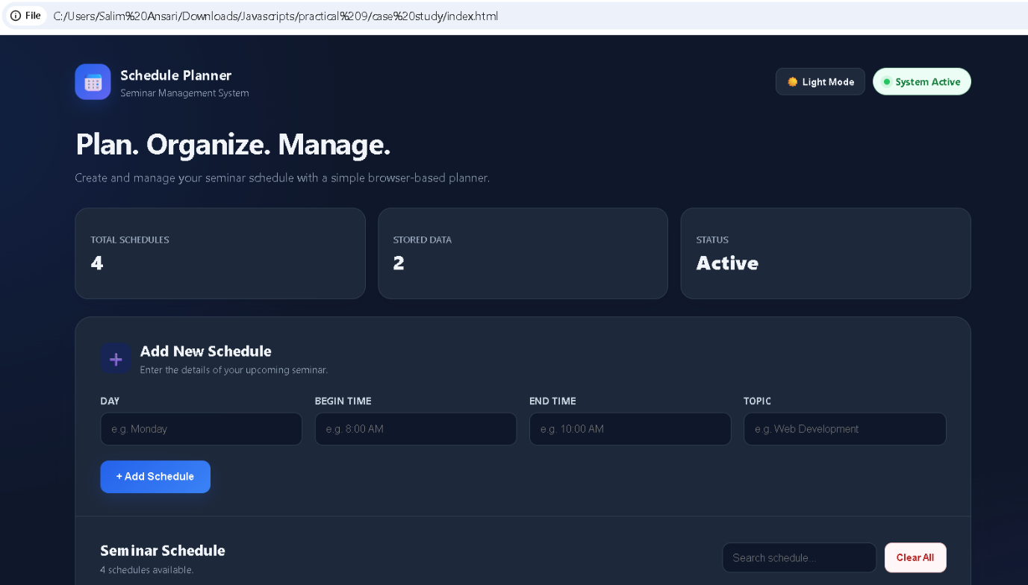
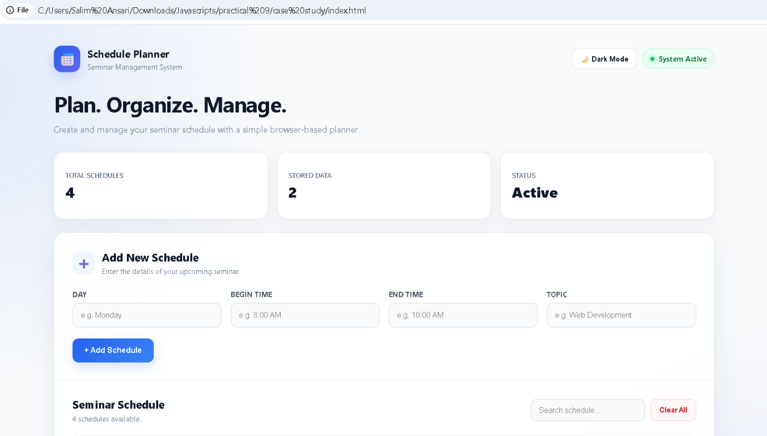
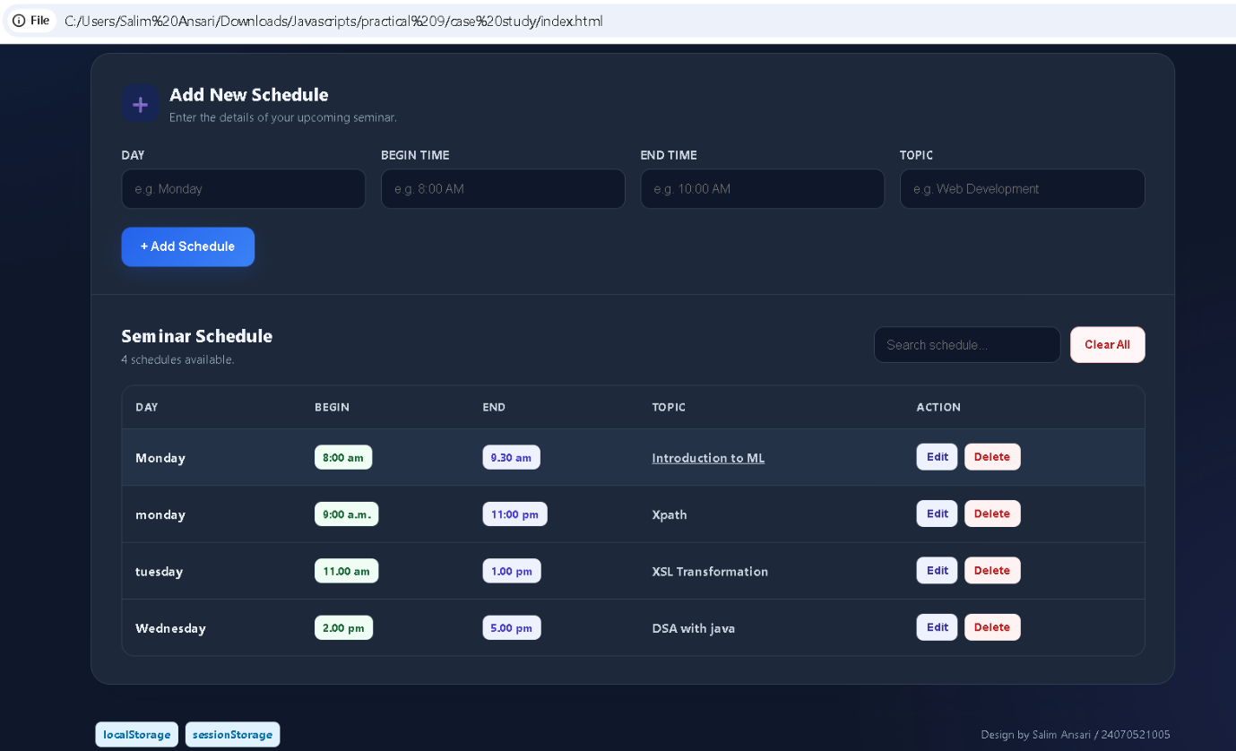
Conclusion –
The experiment successfully demonstrated web storage and JavaScript click events through theme preferences and a Schedule Planner.

